Set theory assignment question 4
Name: Enter your name here
Acknowledgements: I received no help from other sources on this assignment question (or:
I received help from XX with question Y part Z...) Due: Monday, January 22nd @ 11:20am.
4. In this question, you’ll see that matrices and matrix multiplication have the same sorts of properties that functions and function composition have. (If you need a quick introduction or review of matrices and matrix multiplication, see the file labelled “matrix muliplication review”.
- Recall that if A is an m × n matrix and B is an n × p matrix, then by matrix multiplication we get a m × p matrix AB. (Note how similar this is to function composition, where given a function f : A → B and g : B → C, we get a new function fg : A → C!). Prove in a particular case that this operation is associative: prove that if A and B are arbitrary 2 × 2 matrices and C is an arbitrary 2 × 1 matrix:
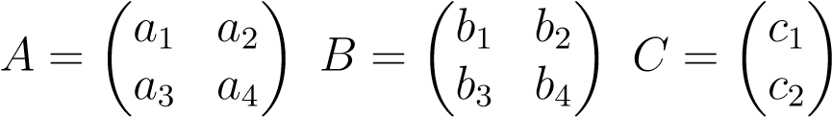
then (AB)C equals A(BC). (That is, prove that if you first multiply A by B, then multiply that result by C, you get the same thing if you first multiply B by C, then multiply that by A).
Solution: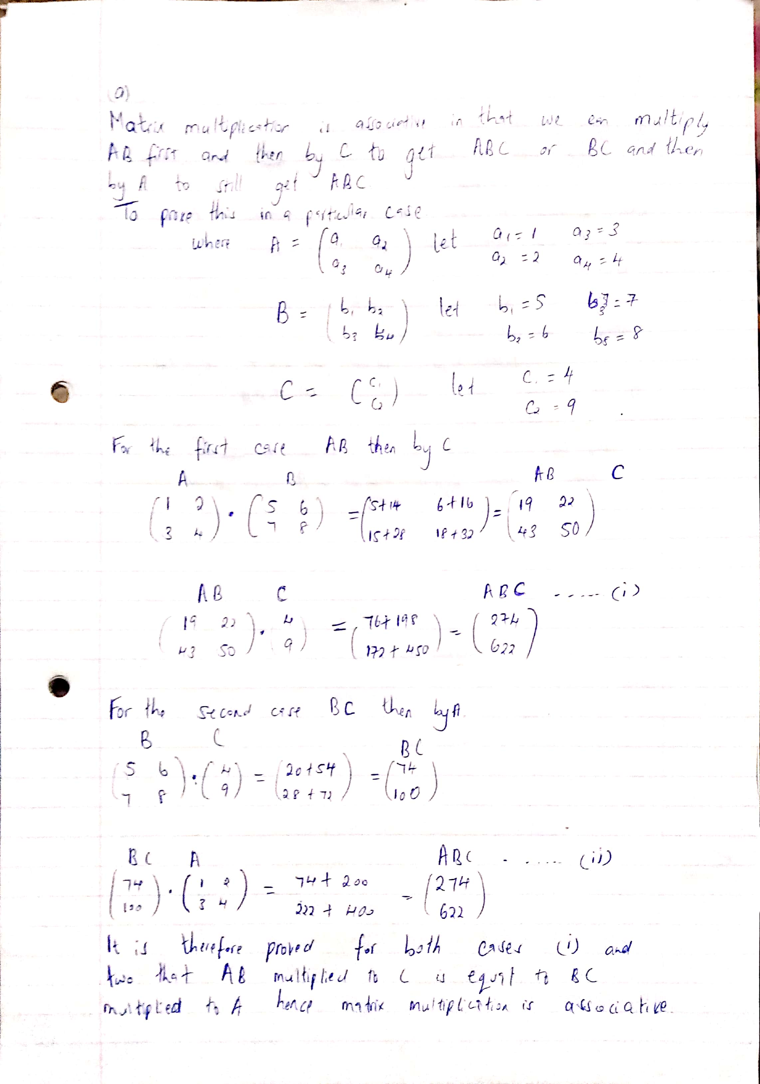
- Prove that this operation is unital: that is, for every natural number n, give a specific n × n matrix E_{n} so that for any n × m matrix A,
E_{n}A = AE_{m} = A.
As always, be sure to prove your claim.
Solution:

